Sophia Wu

DXARTS 472 A

5/17/23

**Proof of concept prototype + demo**

**DALL-E Process:**

Picking and Choosing from 4 Iterations

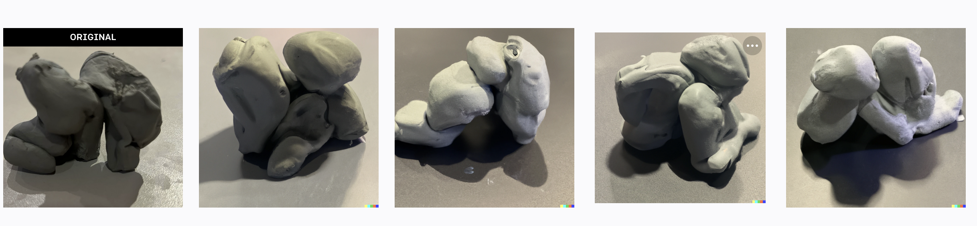

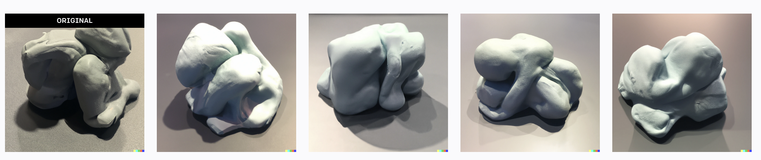

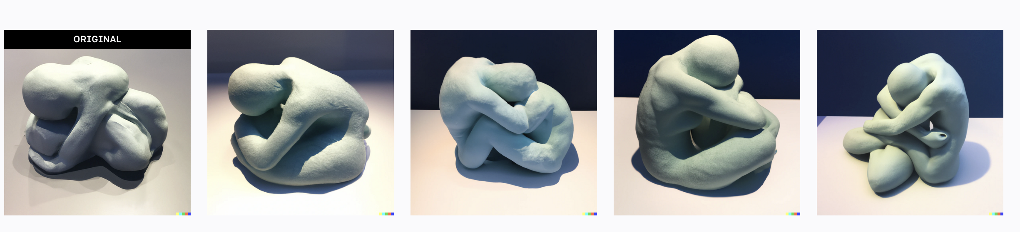

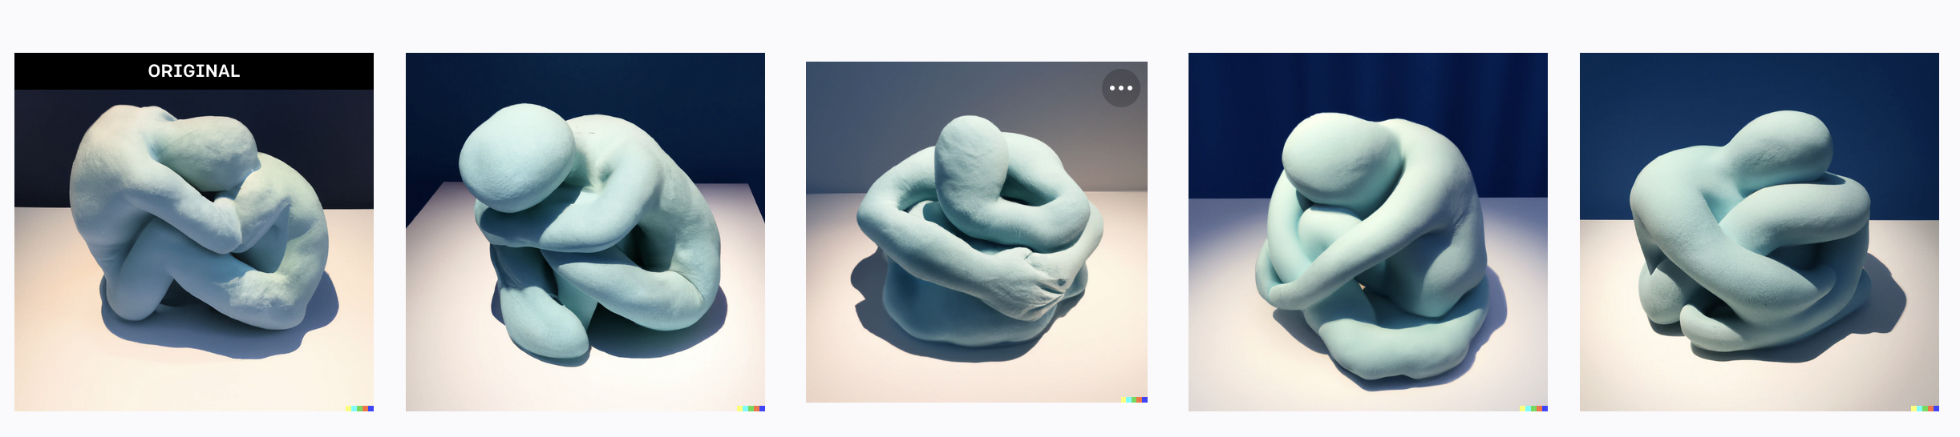

**3d Modeling Process:**

Tracing and Inflating Image in Monster Mash

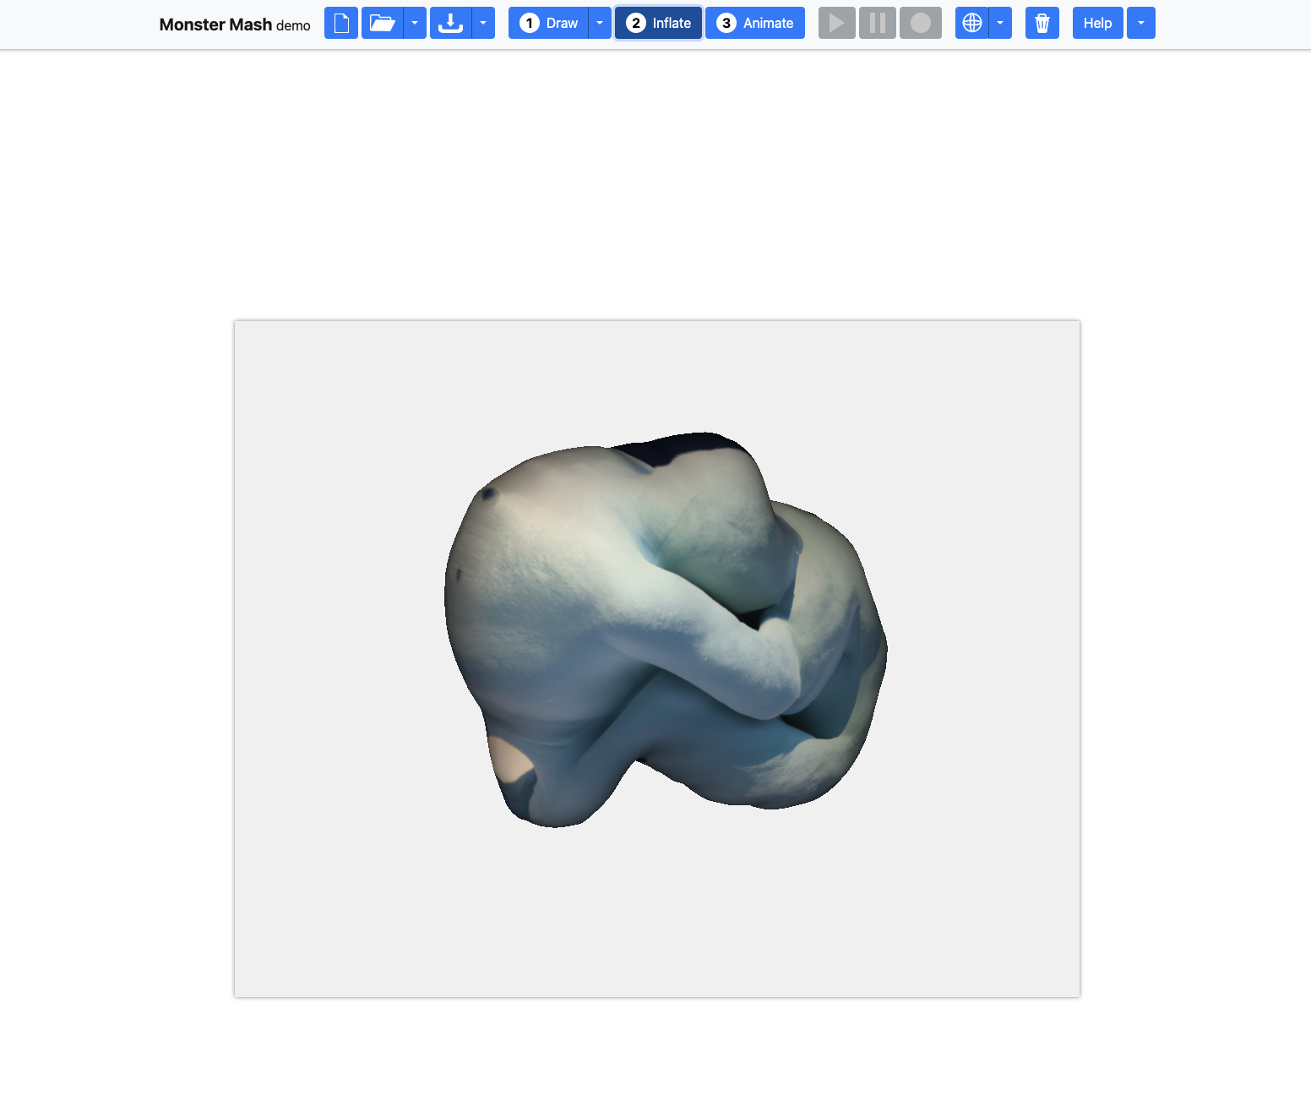

Re-shape and Edit Model in Blendr

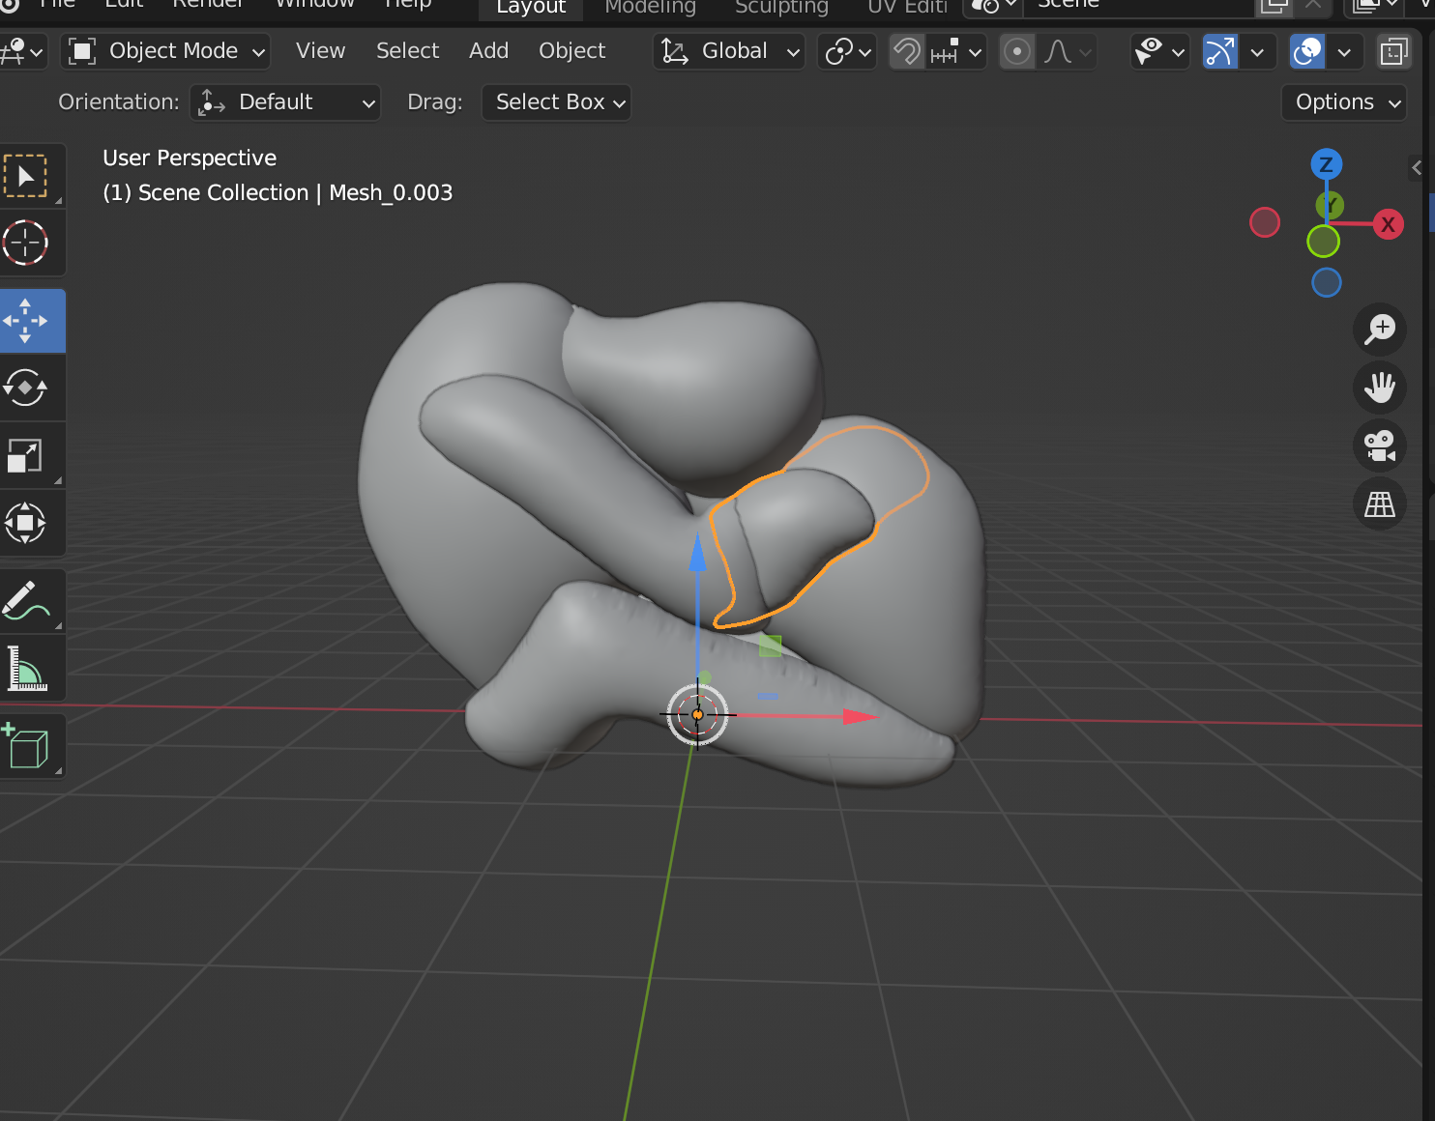

Add Model into Slicer for 3D Printing

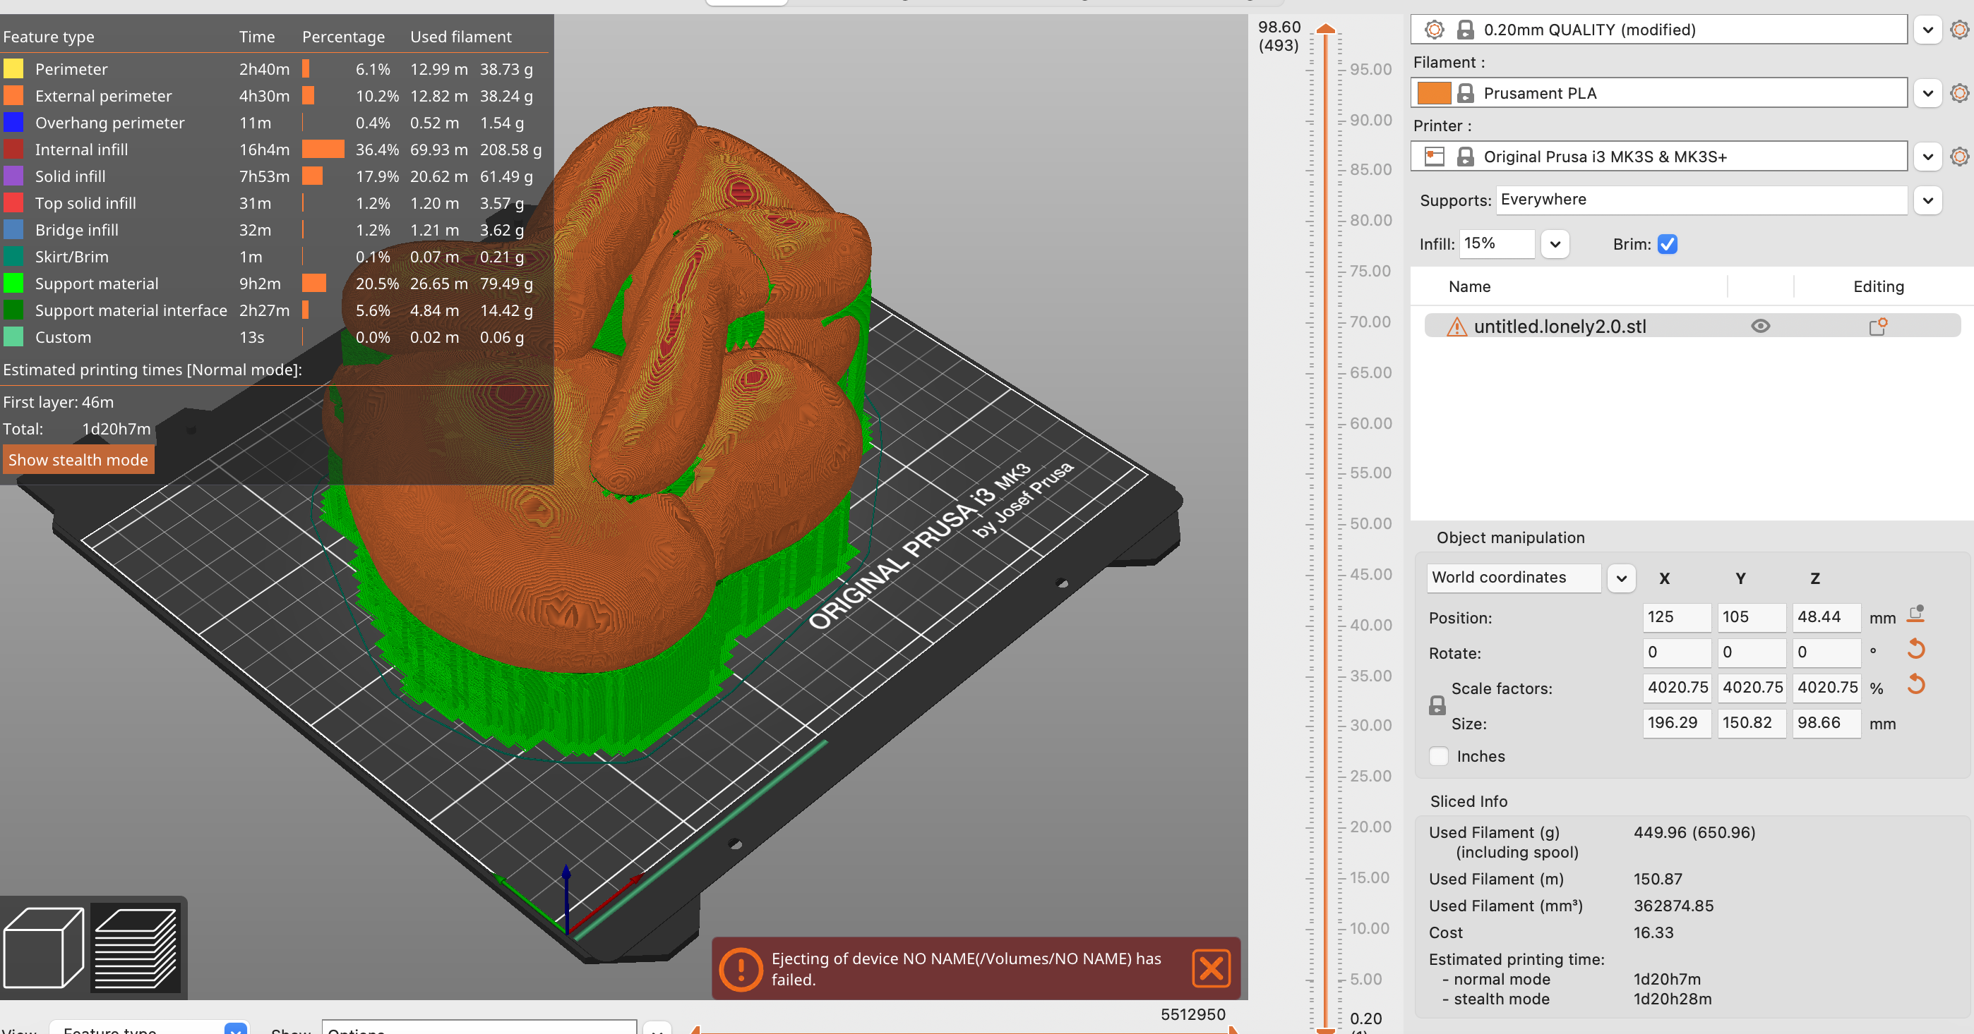

Printed Prototype:

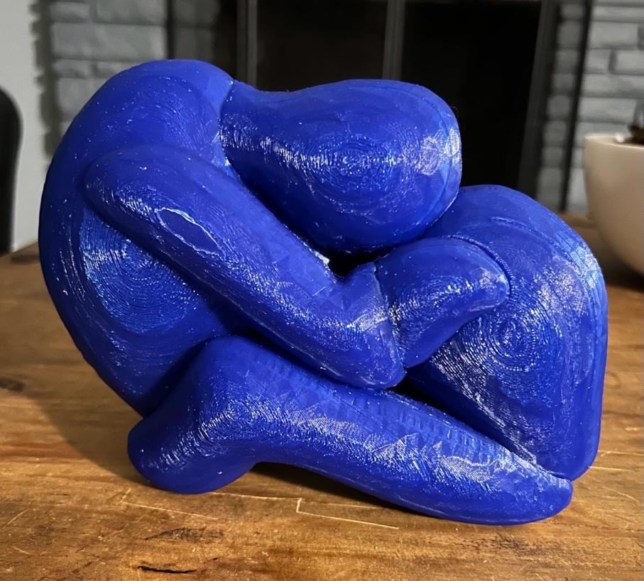

Sanded and Painted prototype:

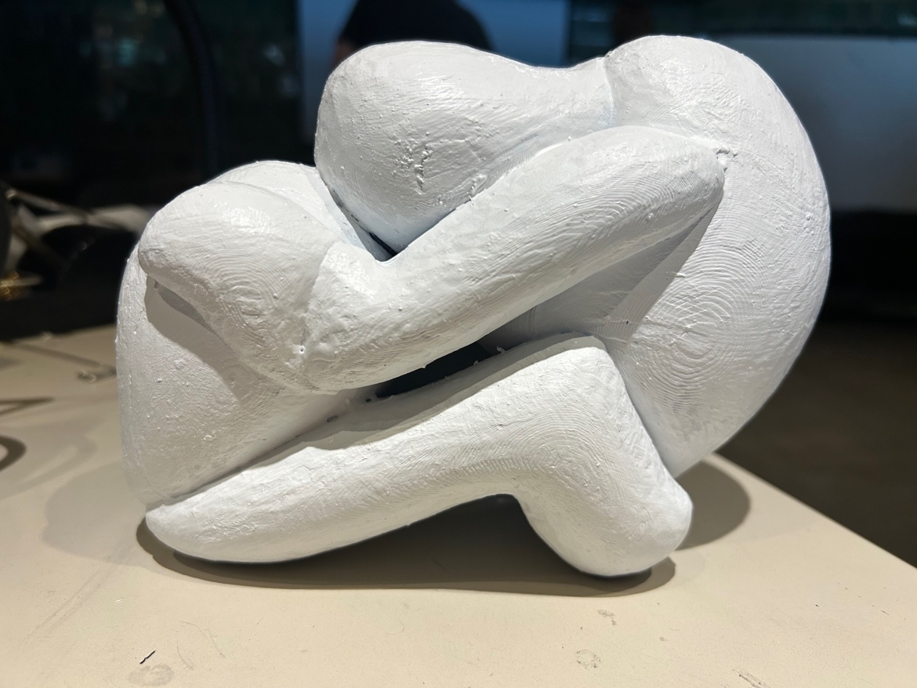

**Approximate Model Size:** 11 x 9 in. (length/height)

**Model Print Time:** 48 hrs

**Future Steps:** Applywood filler to model, paint with primer and sand for a smoother surface. Repaint the model to the color seen in picture for more similarity. When moving forward with the second model, print the model in separate pieces (either in halves or several parts). Sand and paint before gluing everything together. Repeat process with first model.

**Final Presentation Plan:** Have at least 2 sculptures with above model size as a minimum. The sculptures will be painted according to the color of ai generated model and have an appearance as close to the ai picture as possible. The sculptures would have a relation to each other, a personal story of the artist about loneliness and feelings of isolation. Present pieces on separate pedestals with pictures of Ai iterations in front of each piece.

**2nd Model Progress:**

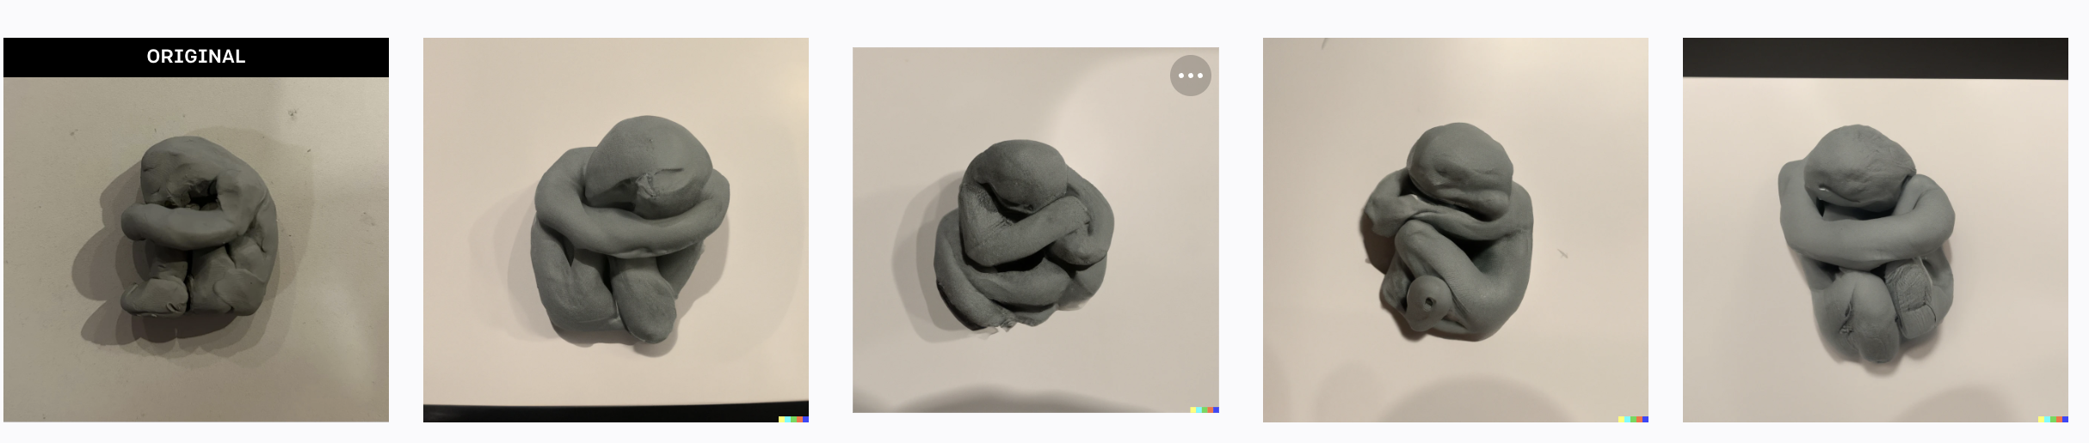

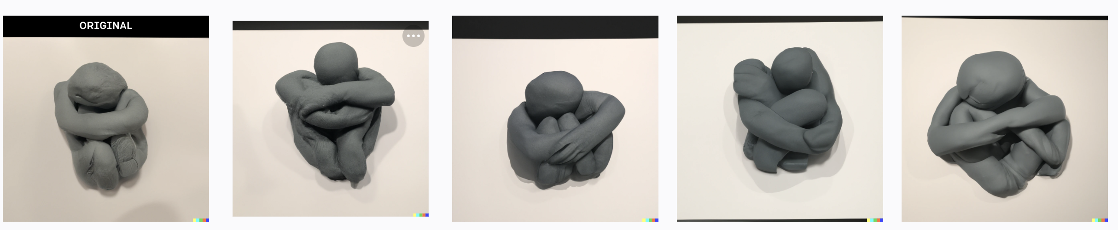

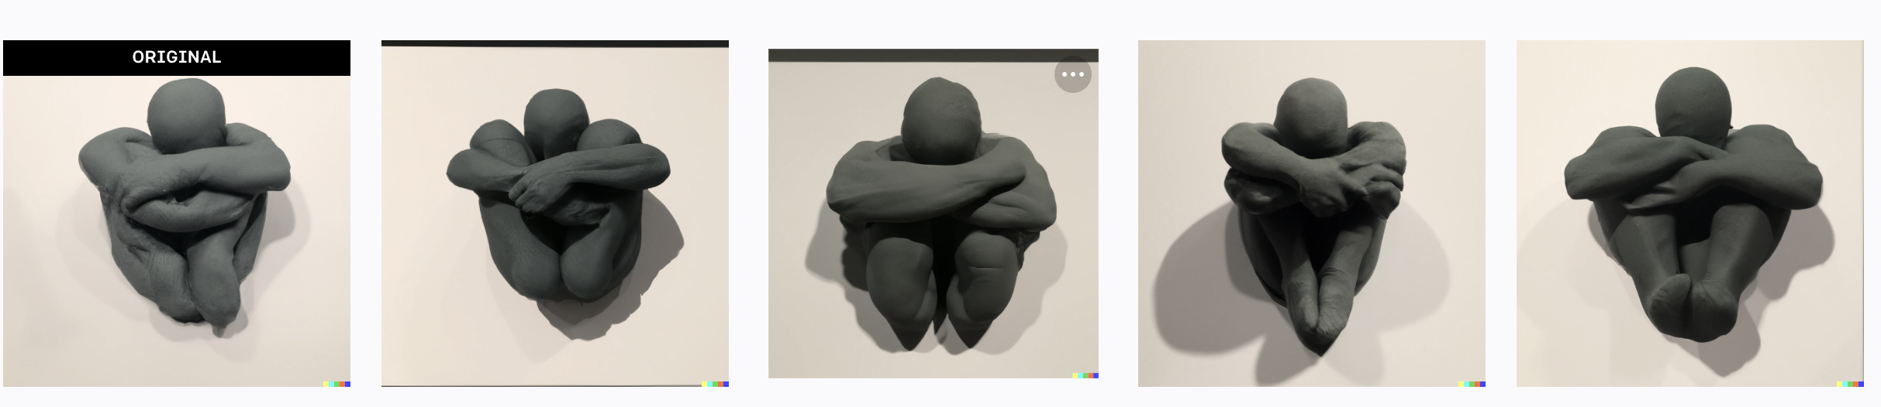

Blendr Process: Building from picture:

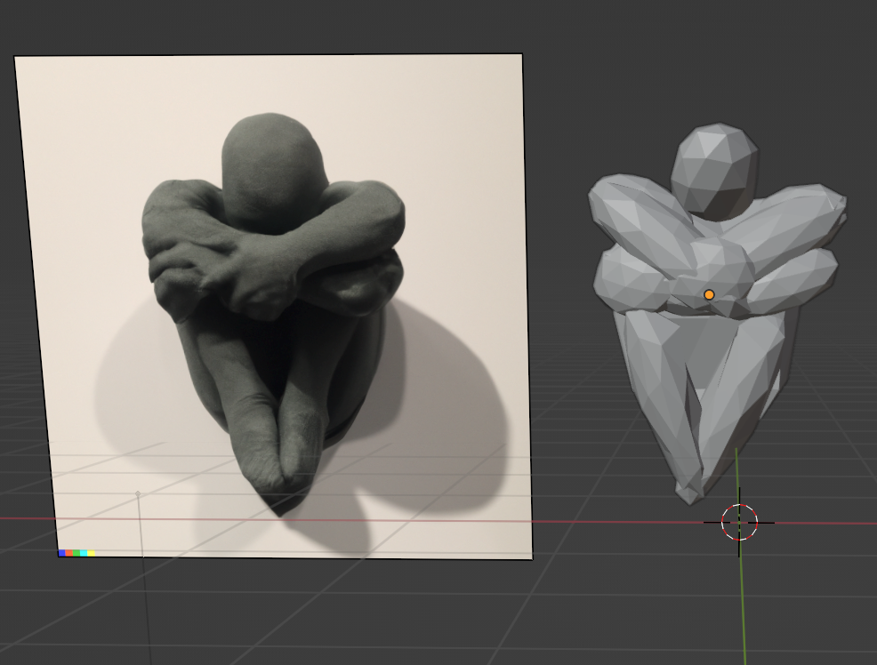

**Approximate Max Printing Time/ Model:** 36 hours

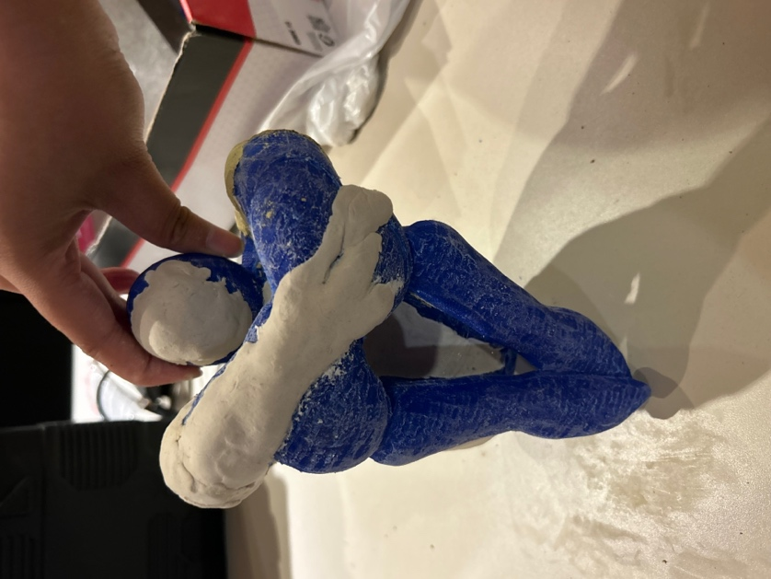Sanded and Printed Prototype: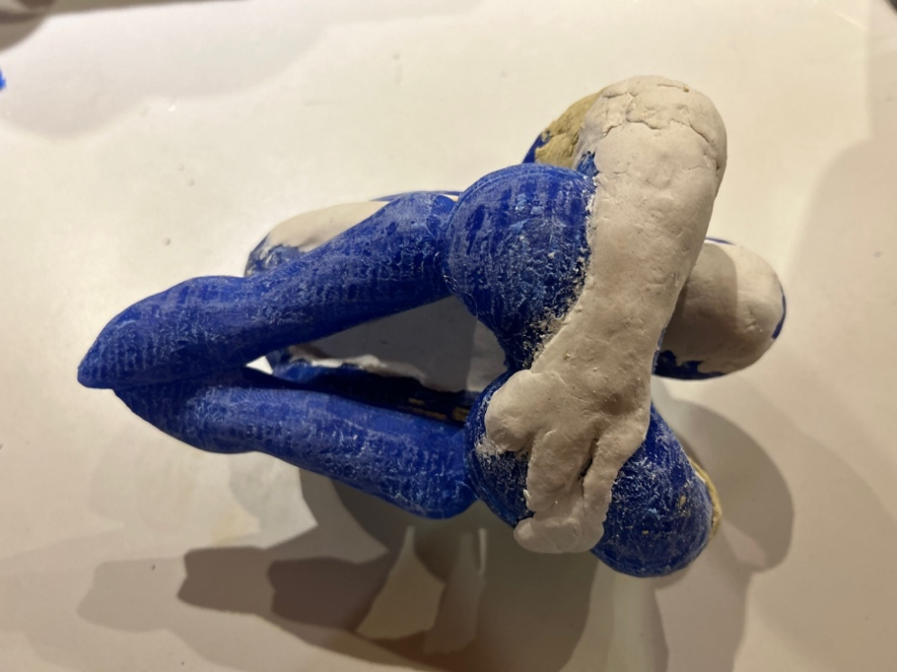

**Initial Budget:** $150

**Budget Spent:** $206.16

* $54 (2 pla filament rolls)
* $16 flexible filament, TPU
* $17.99 mold Making silicon kit (failed)
* $3 donation for smoothie (3d modeling platform)
* $15 credit for DALL-E
* $40 Kaedim (makes 3d model from picture through ai/failed)
* $26 Colored cardstock paper for exhibition
* $17 Creative paperclay
* $6.19 White Primer spray
* $10.98 Gorilla All-purpose wood filler